

ITA0330-Mobile Computing
Name: -G. Akshya Reg no: -192425132
Slot: -D Course Name: -Mobile Computing

Experiment 10: Multiple Access Techniques Using Figma

Aim

To create a visual representation in Figma showcasing the differences between various multiple access techniques used in mobile communication.

Procedure

- Open Figma and create a new design frame.
- Add the heading Multiple Access Techniques at the top.
- Create five coloured sections for FDMA, TDMA, CDMA, OFDMA, and SDMA.
- Write the full form of each technique below its heading.
- Draw simple diagrams to represent how each technique shares communication resources.
- Add brief points explaining the working principle of each technique.
- Apply different background colours to distinguish the five techniques.
- Align all sections properly and maintain consistent spacing.
- Preview the final design and check the readability of the text and diagrams.

Output: -
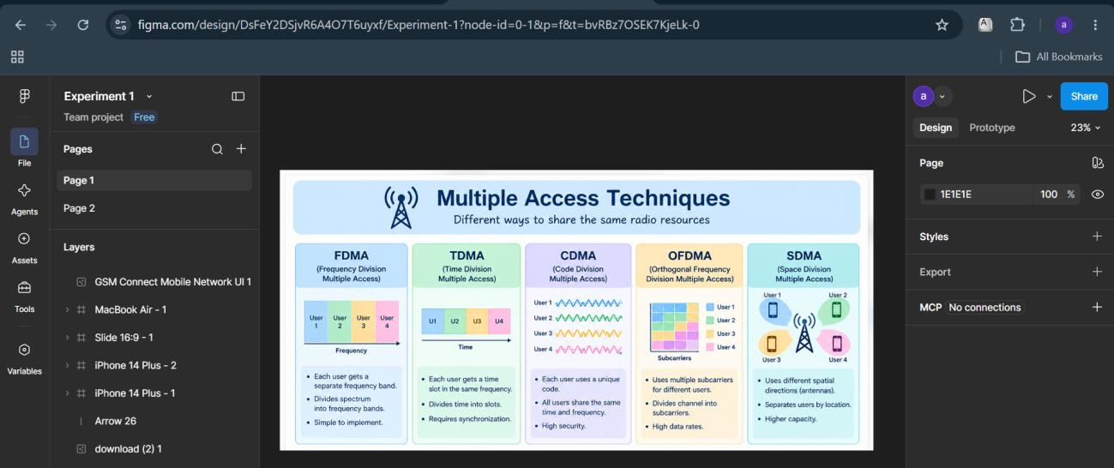

https://www.figma.com/design/DsFeY2DSjvR6A4O7T6uyxf/Experiment-1?node-id=0-1&p=f&t=bvRBz7OSEK7KjeLk-0

Result: -The visual representation of multiple access techniques was successfully created in Figma. The infographic illustrates FDMA, TDMA, CDMA, OFDMA, and SDMA using simple diagrams and explanations. The design helps compare how different techniques allocate radio resources in mobile communication.

